**E-Voting App**

**Lecturer: Khayyam Masiyev**

**Course Name: Software Engineering**

**Group Students: Sevar Jafarli, Ayaz Panahov**

**Requirements List**

1. **User system**

* **Registration** – New users should be added to the database when they register by entering the valid registration input. (U.R)

**All the registration data (user’s credentials) will be stored on the cloud (S**.R)

* + - **User input** – Users need to enter inputs like email and password when they register to the app. (S.R)
* Password should be minimum of 6 characters including uppercase and lowercase letters and numbers. (F.R)
* No personal information will be shared with third parties. (N.F.R)
* Passwords will be stored in Firebase cloud in a strongly hashed format. (S.R)
* **Login –** registered users will have a email and password to login the system. (U.R)
  + - **Front-end –** A user-friendly interface for easy login. (S.R)
      * **User input –** Already registered users need to enter email and password login. (S.R)
* Display an error message if username or password is wrong. (F.R)

**2.Voting System**

* **Public and anonymous­­ voting – The application will give users 2 options for voting: public and anonymous. (U.R)**

**If the e­lection is held publicly, all the voting data will be open to users.**

**On the other hand, if it’s anonymous election, no data will be shared with others. Only the winner of voting will be reveled at the end of election.**

* **Authenticity – Several solutions will be used for protecting authenticity.**
* **Integrity/accuracy**

No voters’ choice should not be disclosed to any user.

If voting is anonymous, voter cannot change his option after completing voting. But, if voting is public, voters can change their choice any time they want before the election finishes. (S.R)

* One user can only participate in one election once. Multiple voting will not be counted.
* Security - Throughout the voting process, a vote can’t be tampered with. All the casted votes will not be stored on a cloud rather, it will be held by blockchain system anonymously for the purpose of decentralization.

**­­3.Categories**

* **Content –** Elections can be in any content provided by system.

Categories are governmental, environmental, social, cultural etc.

Users will be able to see current voting elections by category in voting category screen.

**4.Search System**

* **By Category**: Users will be able to search for elections by category. For example, governmental, cultural etc. (U.R)
* **By Name:** Users will also be able to search by the name of election.

**5.Notification System**

* **New, upcoming elections:** Users will receive pop-up notifications about new elections. (U.R)
* **Finished elections: Users will also receive notifications if the election finished and results are disclosed.**

**UML Diagram**

**ER Diagram**

**Sequence Diagrams**

*Registration:*

*Login:*

**Product Backlog**

**Use Cases**



**Design**

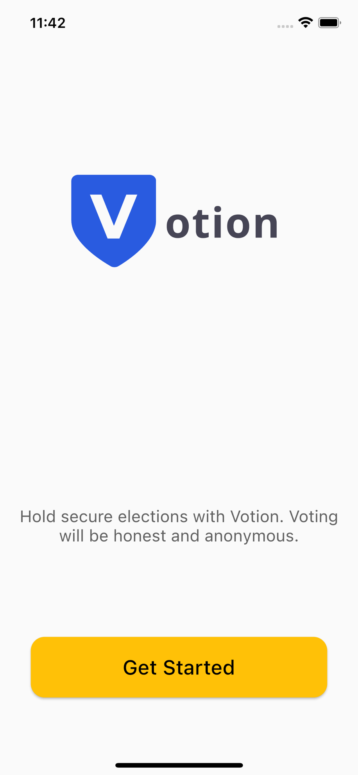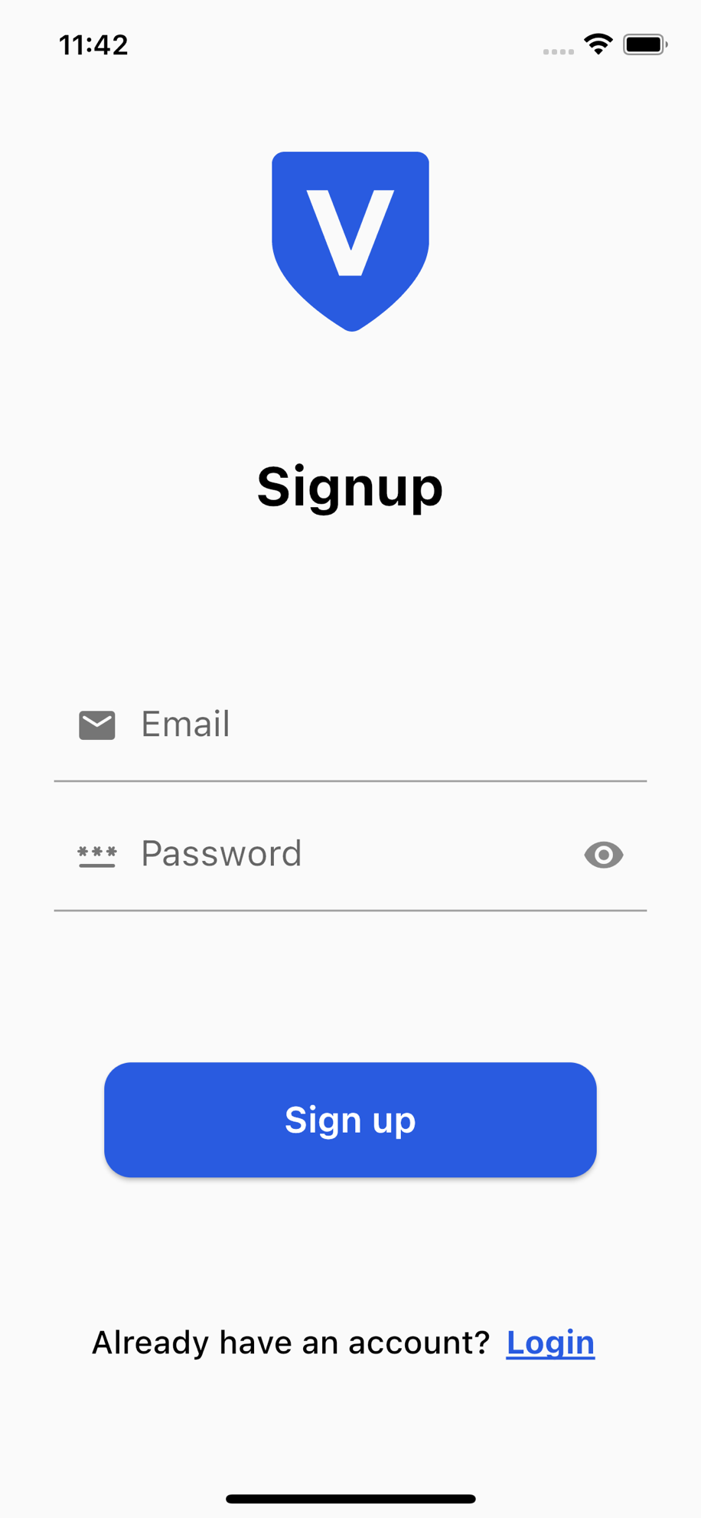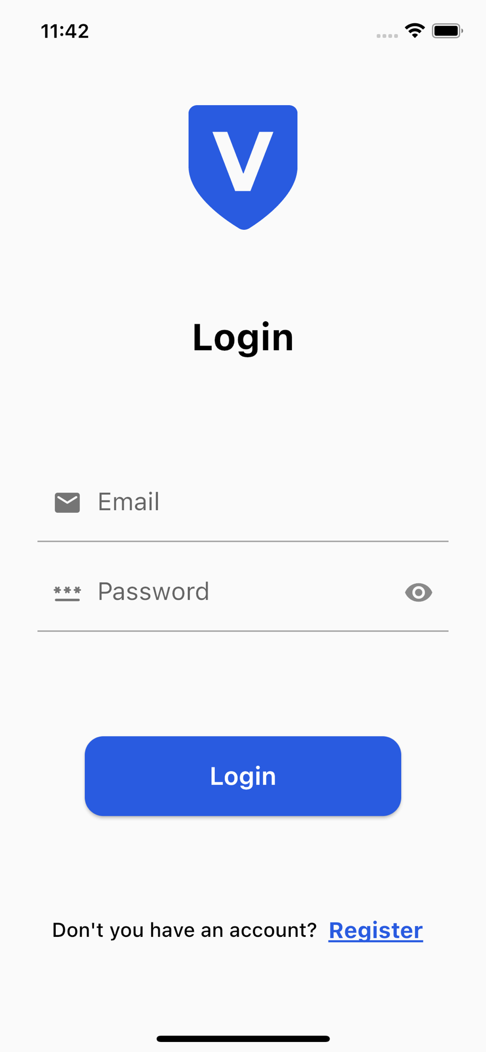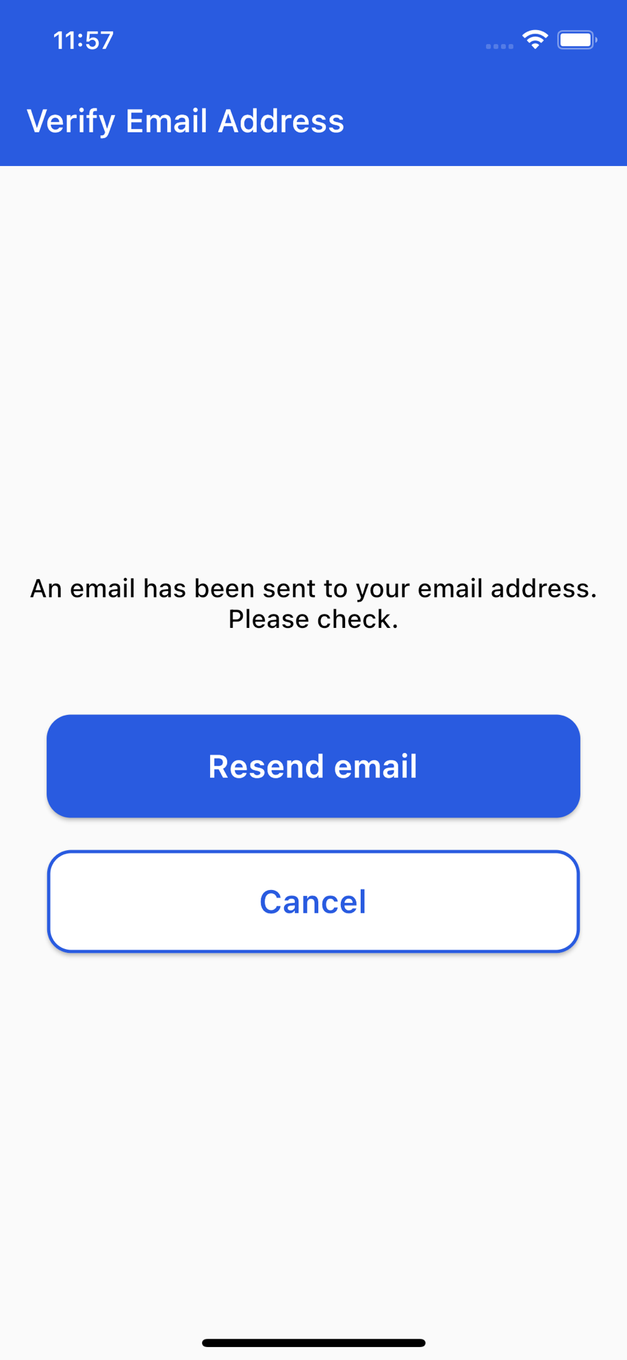

­­­­­­­­­­­

*Github link:* [*https://github.com/SevarJafarli/E-Voting-App.git*](https://github.com/SevarJafarli/E-Voting-App.git)

All the materials related to the application can be found in the link above.